Launch of ec2 instance
- login to aws cloud from browser
- Then search for Ec2 in search bar
- Then click on instance then create a new instance
or launch new instance
- Select free eligble tiers
- Such as t3.micro and select custom keypair and
download pem file for security
- Then click on launch instance

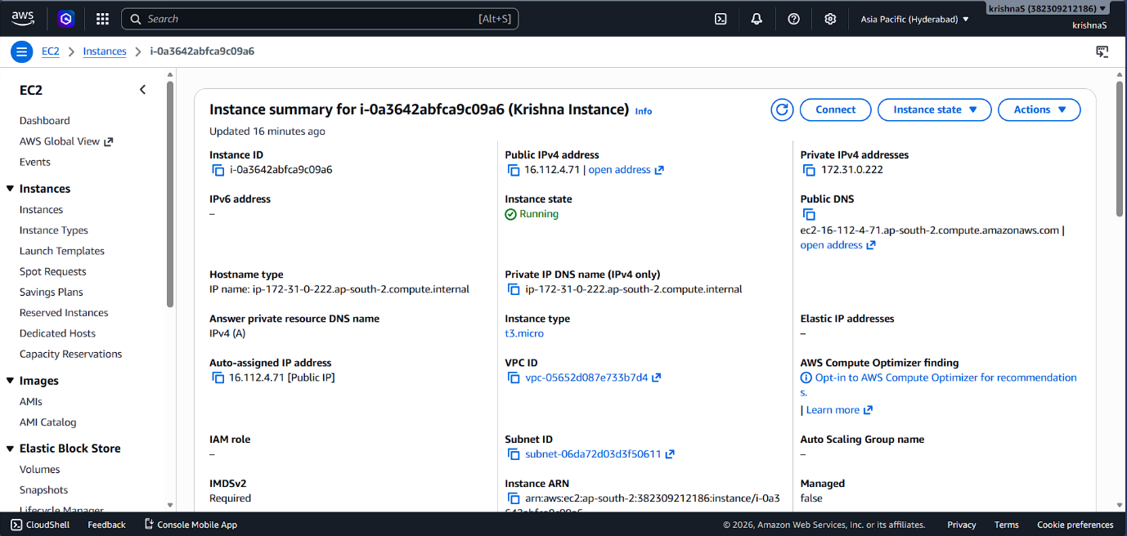

Installing jenkins in windows
- Download Jenkins windows msi installer package from
jenkins website.
- Run the jenkins package after downloading.
-download and install java jdk21 from java website.
- install jenkins application then in
setup browse java path and select then create a
username and password for the jenkins admin
- Default jenkins password is shown in setup page
just copy and open jenkins make port number
8080
- Then just type hostname:8080 in chrome now you
can see jenkins running
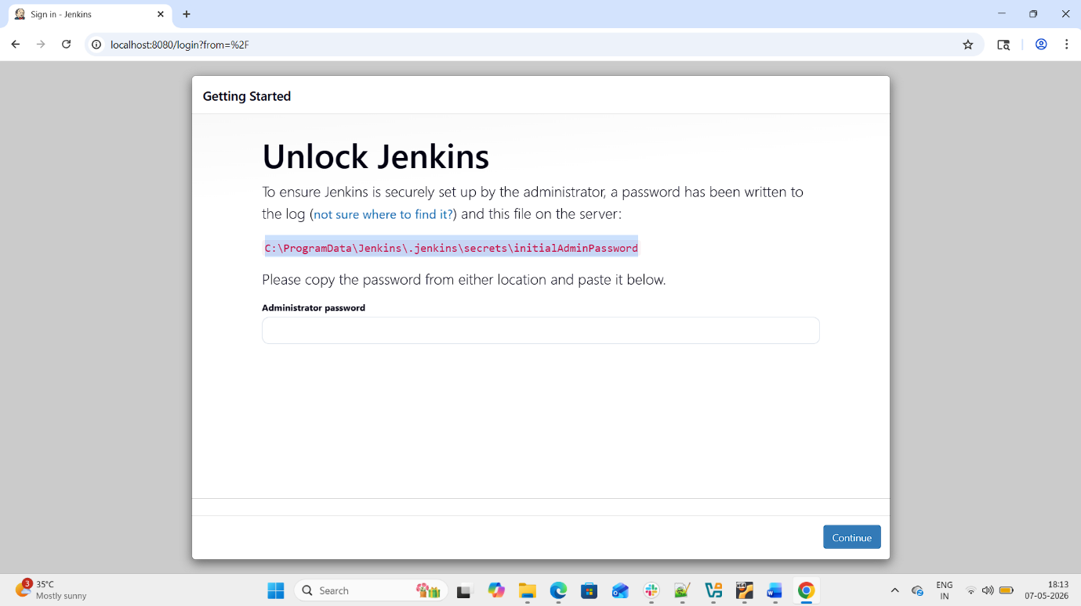

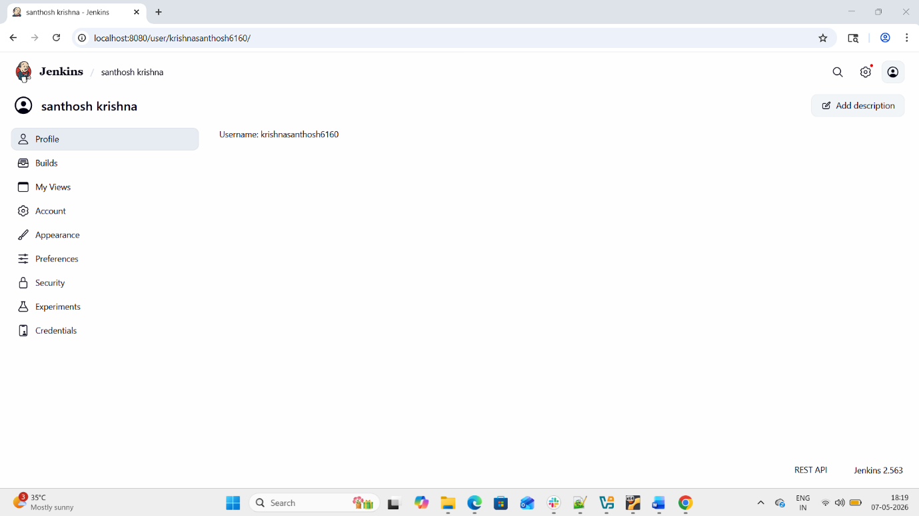

Installing apache tomcat in ubuntu
- Open ubuntu terminal and first update
(Sudo apt update)
- install java using command Sudo apt install default-jdk
- check java version using command
Java --version
- Then search for tomcat in terminal with
command
Sudo apt search tomcat
- Then we can install tomcat with command
sudo apt install tomcat11 tomcat11-admin
With this the tomcat has installed succesfully
- To check tomcat is running or not
Use the command ps –ef|grep –i tomcat
- Now we have succesfully installed tomcat to
know we can go to mozilla firefox and search
hostname:8080 it will show it works

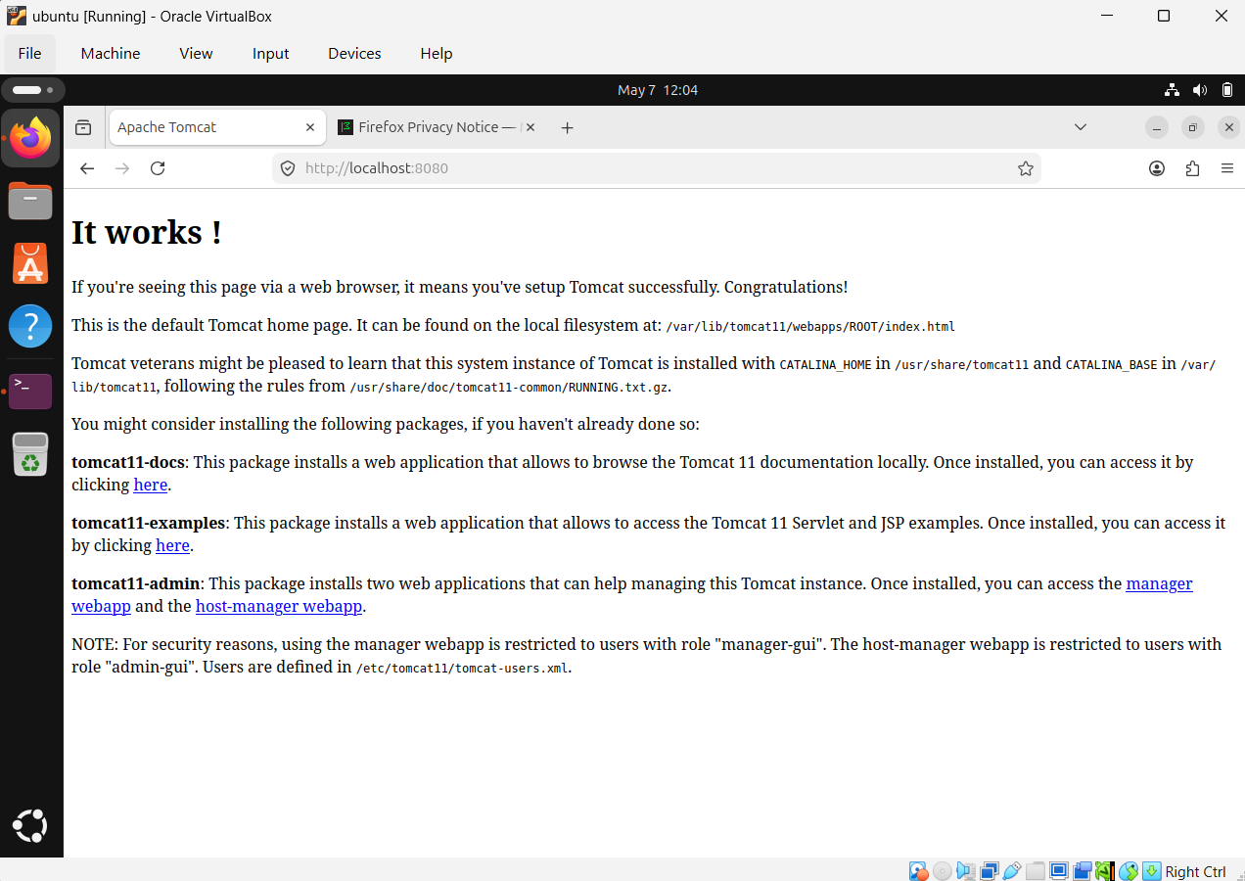

Installing desktop docker in windows
- Go to docker website and download package
for your pc
- Just install docker app and continue through
setup
- And after completing installation restart your
computer to complete the installation
- After restart open desktop docker and create
an account in docker desktop and website
- And make sure your wsl is updated
- To update open cmd and input command
Wsl – update
- Now open desktop docker.

